CR-05 - Goals and Outcomes
Progress the jurisdiction has made in carrying out its strategic plan and its action plan. 91.520(a)
This could be an overview that includes major initiatives and highlights that were proposed and executed throughout the program year.

During the 2020 program year, CBG funding allocations focused on promoting the stability of the community during the coronavirus pandemic through grants to local businesses, grants to non-profit organizations, and utility assistance to residents. Additionally, significant updates and improvements were made to the administrative procuredures and processes within the department to promote efficiency and regulatory compliance moving forward.
Economic Development: The City had originally intended on expending a significant portion of the 2020 CDBG budget for economic development activities. Fortunately, City staff successfully secured an additional grant award through the Department of Commerce and Economic Opportunity (DCEO) in the amount of up to $881,000 for use in reimbursing general operating expenses for community businesses that had applied for the City’s business assistance grant program. CDBG funding and DCEO funding were used in tandem to allow the City to provide assistance to businesses while also preserving a large portion of CDBG funding to be used to address additional community needs.
Public Services (Grants to Community Organizations): Two grants were provided to local shelters that provide housing, basic necessities, counseling and casework services for individuals and families experiencing homelessness. During the 2021 program year, the CDBG department intends to utilize an updated grant proposal process to expand the variety of organizations provided with an opportunity to secure CDBG funding.
Public Services (Direct Assistance to Residents): A utility assistance program was established to provide assistance to LMI households with unpaid utility bills. To ensure compliance with HUD requirements, the assistance was limited to unpaid bills not to exceed 6 months worth of assistance. While public participation and the overall number of eligible bills were not as significant as originally anticipated, this City was still able to provide much needed assistance to 83 households within the community in an effort to prevent shutoffs as we move out of pandemic-related restrictions.
Public Facilities and Improvements: Certain improvements were deemed necessary to City-owned facilities to ensure the safety of fire department staff during the coronavirus pandemic. To assist with this effort, the City utilized CDBG funding received as part of CARES Act funding to reduce the chance of coronavirus spread in the living quarters of community fire department facilities.
Owner-Occupied Rehabilitation: Despite significant delays due impacts of the coronavirus pandemic, the City was able to complete work on one carryover residential rehabilitation project that has been pending since 2018. This project included the installation of new entry doors, windows, siding, gutters, and additional electrical/plumbing work to ensure the safety of residents. One additional residential rehabilitation project is planned for the 2021 program year which has also been carried over from the previous program year.
Comparison of the proposed versus actual outcomes for each outcome measure submitted with the consolidated plan and explain, if applicable, why progress was not made toward meeting goals and objectives. 91.520(g)
Categories, priority levels, funding sources and amounts, outcomes/objectives, goal outcome indicators, units of measure, targets, actual outcomes/outputs, and percentage completed for each of the grantee’s program year goals.

Goal | Category | Source / Amount | Indicator | Unit of Measure | Expected – Strategic Plan | Actual – Strategic Plan | Percent Complete | Expected – Program Year | Actual – Program Year | Percent Complete
Address Blighted Property Issues | Non-Housing Community Development | CDBG: $ | Buildings Demolished | Buildings | 25 | 0 | 0.00% | 7 | 0 | 0.00%
Administration | Planning | CDBG: $ / CDBG-CV: $ | Other | Other | 1 | 1 | 100.00% | 1 | 1 | 100.00%
Improve Facility, Utility, and Amenity Access | Non-Housing Community Development | CDBG: $ | Public Facility or Infrastructure Activities other than Low/Moderate Income Housing Benefit | Persons Assisted | 200 | 0 | 0.00%
Improve Facility, Utility, and Amenity Access | Non-Housing Community Development | CDBG: $ | Other | Other | 0 | 0 |  | 1 | 1 | 100.00%
Improve Fire Safety | Non-Housing Community Development | CDBG: $ / CDBG-CV: $0 | Other | Other | 1 | 0 | 0.00% | 1 | 0 | 0.00%
Improved Economic Environment | Non-Housing Community Development | CDBG: $ / CDBG-CV: $ | Businesses assisted | Businesses Assisted | 15 | 27 | 180.00% | 15 | 27 | 180.00%
Prevent, Prepare For, and Respond to Coronavirus | Non-Housing Community Development | CDBG: $ / CDBG-CV: $ | Public Facility or Infrastructure Activities other than Low/Moderate Income Housing Benefit | Persons Assisted | 0 | 0 |  | 1 | 1 | 100.00%
Prevent, Prepare For, and Respond to Coronavirus | Non-Housing Community Development | CDBG: $ / CDBG-CV: $ | Other | Other | 1 | 1 | 100.00% | 0 | 0
Provide Quality, Safe and Accessible Housing | Affordable Housing | CDBG: $ | Homeowner Housing Rehabilitated | Household Housing Unit | 2 | 1 | 50.00% | 2 | 1 | 50.00%
Sustain or Expand Services and Direct Assistance | Affordable Housing  Homeless  Non-Homeless Special Needs  Non-Housing Community Development | CDBG: $ / CDBG-CV: $ | Public service activities other than Low/Moderate Income Housing Benefit | Persons Assisted | 0 | 0 |  | 0 | 0
Sustain or Expand Services and Direct Assistance | Affordable Housing  Homeless  Non-Homeless Special Needs  Non-Housing Community Development | CDBG: $ / CDBG-CV: $ | Public service activities for Low/Moderate Income Housing Benefit | Households Assisted | 500 | 202 | 40.40% | 500 | 202 | 40.40%
Sustain or Expand Services and Direct Assistance | Affordable Housing  Homeless  Non-Homeless Special Needs  Non-Housing Community Development | CDBG: $ / CDBG-CV: $ | Homelessness Prevention | Persons Assisted | 0 | 0 |  | 0 | 0
Table 1 - Accomplishments – Program Year & Strategic Plan to Date

Assess how the jurisdiction’s use of funds, particularly CDBG, addresses the priorities and specific objectives identified in the plan, giving special attention to the highest priority activities identified.

CR-10 - Racial and Ethnic composition of families assisted
Describe the families assisted (including the racial and ethnic status of families assisted). 91.520(a)

 | CDBG
White | 147
Black or African American | 49
Asian | 0
American Indian or American Native | 2
Native Hawaiian or Other Pacific Islander | 2

Total | 200

Hispanic | 7
Not Hispanic | 196

Table 2 – Table of assistance to racial and ethnic populations by source of funds

Narrative
Numerous families were assisted through activities during the 2020 program year. Employees, small business owners, homeowners, renters, and individuals experiencing homelessness were the primary beneficiaries of CDBG funding during this program year. Of note, two beneficaries entered "other multi-racial" and one beneficary entered "black and white" for their race and ethnic status whcich are not a selection in the HUD reporting system making a toal of 203 families assisted.

CR-15 - Resources and Investments 91.520(a)
Identify the resources made available
Source of Funds | Source | Resources Made Available | Amount Expended During Program Year
CDBG | public - federal | 911,973 | 208,853
Other | public - federal | 447,494 | 171,458
Table 3 - Resources Made Available

Narrative
The City of Pekin does not receive funding from HOME, HOPWA, ESG or other HUD programs. The City did receive an allocation from the CARES Act in the amount of $447,494.00 as indicated in the "Other" funding category.

Identify the geographic distribution and location of investments
Target Area | Planned Percentage of Allocation | Actual Percentage of Allocation | Narrative Description
City of Pekin | 100 | 100 | Community wide investment of CDBG
Table 4 – Identify the geographic distribution and location of investments

Narrative

Leveraging
Explain how federal funds leveraged additional resources (private, state and local funds), including a description of how matching requirements were satisfied, as well as how any publicly owned land or property located within the jurisdiction that were used to address the needs identified in the plan.
While there are no federal matching requirements for CDBG funding, the City did leverage an additional grant award allocation of up to $881,000 from the State of Illinois to support community businesses. Additionally, community organization subrecipients reported matching resources in the amount of $36,784 to supplement CDBG funding. Both subrecipient organizations also leveraged existing staff, facilities and resources to carry out funded programs.

CR-20 - Affordable Housing 91.520(b)
Evaluation of the jurisdiction's progress in providing affordable housing, including the number and types of families served, the number of extremely low-income, low-income, moderate-income, and middle-income persons served.

 | One-Year Goal | Actual
Number of Homeless households to be provided affordable housing units | 0 | 0
Number of Non-Homeless households to be provided affordable housing units | 2 | 1
Number of Special-Needs households to be provided affordable housing units | 0 | 0
Total | 2 | 1
Table 11 – Number of Households

 | One-Year Goal | Actual
Number of households supported through Rental Assistance | 0 | 0
Number of households supported through The Production of New Units | 0 | 0
Number of households supported through Rehab of Existing Units | 2 | 1
Number of households supported through Acquisition of Existing Units | 0 | 0
Total | 2 | 1
Table 12 – Number of Households Supported

Discuss the difference between goals and outcomes and problems encountered in meeting these goals.
The City completed the work associated with one of two carryover rehabilitation projects during the program year. It was hoped that it would be possible to complete both projects as they are carryovers from 2018, however, delays associated with a focus on responding to the coronavirus pandemic along with project-specific delays associated with the first project resulted in a need to delay the undertaking of the remaining rehabilitation project until the following program year.
Discuss how these outcomes will impact future annual action plans.
The CDBG Program Manager is currently assessing alternative methods of undertaking this activity to improve efficiency such as the engagement of a community housing development organization (CHDO). As of this time, the City will not be undertaking additional residential rehabilitation applications during the 2021 CDBG program year. The City has traditionally undertaken residential rehabilitation projects with mixed results and it is hoped that an alternate method of delivery may improve the outcomes associated with this project type. The City may also consider alternative funding sources for this type of activity as opposed to exclusively utilizing CDBG funds.
During the process of completing the 2020 program year rehabilitation activity, it was observed that there was a lack of qualified bidders despite publication of a bid request, were significant delays during the project related to coronavirus, and were further delays associated with material availability. While some of the aforementioned delays were unique to the current operating environment, it is also evident that there has historically been issues with the timely completion of these activities due to various issues that present with residential rehabilitation projects of similar scope. At this time, it has been recommended by City staff that funding can be more efficiently utilized to address other high-priority needs within the community.
Include the number of extremely low-income, low-income, and moderate-income persons served by each activity where information on income by family size is required to determine the eligibility of the activity.

Number of Households Served | CDBG Actual | HOME Actual
Extremely Low-income | 1 | 0
Low-income | 0 | 0
Moderate-income | 0 | 0
Total | 1 | 0
Table 13 – Number of Households Served

Narrative Information

CR-25 - Homeless and Other Special Needs 91.220(d, e); 91.320(d, e); 91.520(c)
Evaluate the jurisdiction’s progress in meeting its specific objectives for reducing and ending homelessness through:
Reaching out to homeless persons (especially unsheltered persons) and assessing their individual needs
The City serves as a non-voting governing board member for the Home For All Continuum of Care organization. The City utilizes contacts within this organization to stay informed of ongoing housing-related concerns and initatives within the region.
Addressing the emergency shelter and transitional housing needs of homeless persons
The City provided CDBG funding to two subrecipient organizations that assist individuals and families experiencing homelessness. The Salvation Army's Rust Transitional Center provides shelter, basic necessities and case management services while the Carol House of Hope operated by the Center for Prevention of Abuse provides similar services to survivors of domestic violence. Each of these organizations maintain extensive networks of cooperative social service agencies to facilitate succesful transition of the individuals utilizing their services. In addition to the grants provided, the City also participates in the Home For All Continuum of Care's annual count of unsheltered homeless.
Helping low-income individuals and families avoid becoming homeless, especially extremely low-income individuals and families and those who are: likely to become homeless after being discharged from publicly funded institutions and systems of care (such as health care facilities, mental health facilities, foster care and other youth facilities, and corrections programs and institutions); and, receiving assistance from public or private agencies that address housing, health, social services, employment, education, or youth needs
In addition to the shelters located within the city limits, the Pekin Housing Authority provides a variety of housing options for displaced, those being discharged from facilities and systems of care as well as those that receive other types of public assistance. The City's participation in the Home For All Continuum of Care allows the City to engage with staff from a variety of social service agencies. One of the primary goals of the continuum of care model is to ensure a fully encompassing service model with coordination through numerous capable agencies to not only assist those experiencing homelessness but to also avoid homelessness for those households that are considered at-risk.
Helping homeless persons (especially chronically homeless individuals and families, families with children, veterans and their families, and unaccompanied youth) make the transition to permanent housing and independent living, including shortening the period of time that individuals and families experience homelessness, facilitating access for homeless individuals and families to affordable housing units, and preventing individuals and families who were recently homeless from becoming homeless again
As previously described, the Home For All Continuum of Care is focused on providing emergency and preventative coordination of assistance for individuals and families who are or are anticipated to be homeless in the near future. Additionally, this coordination identifies and provides for the best possible assistance to those who would be considered chronically homeless.

CR-30 - Public Housing 91.220(h); 91.320(j)
Actions taken to address the needs of public housing
The Pekin Housing Authority (PHA) provides for the needs of its residents and is considered generally capable of addressing the needs of public housing within the community, including residents with accessibility concerns. The PHA develops both an annual and five-year plan describing how they will address the needs of public housing and ensure quality housing for residents. The PHA is governed by a board of commissioners as well as a resident advisory council to undertake the decisionmaking process. The PHA also maintains a full-time resident services coordinator who assists residents with a variety of needs including transportation and employment considerations.
Actions taken to encourage public housing residents to become more involved in management and participate in homeownership
In addition to the PHA's resident advisory council, the PHA's board of commissioners includes one resident position which provides for representation of residents in the management process. As possible, the PHA also provides opportunities for residents to participate in financial education workshops, housing-related counseling and other activities to encourage resident involvement and promote home ownership.
Actions taken to provide assistance to troubled PHAs
The Pekin Housing Authority has not been designated as a troubled PHA.

CR-35 - Other Actions 91.220(j)-(k); 91.320(i)-(j)
Actions taken to remove or ameliorate the negative effects of public policies that serve as barriers to affordable housing such as land use controls, tax policies affecting land, zoning ordinances, building codes, fees and charges, growth limitations, and policies affecting the return on residential investment. 91.220 (j); 91.320 (i)
The City of Pekin has established a Human Rights Committee to consider and provide input on policies which may potentially impact members of the community (and property owners) in a negative manner. The City's use of CDBG funding for residential rehabilitation, public facilities, public services, economic development, infrastructure improvements and demolition activities is anticipated to promote a positive return on residential investment while also improving home affordability for those who are already homeowners.
Actions taken to address obstacles to meeting underserved needs. 91.220(k); 91.320(j)
During the development of the 2020-2024 Consolidated Plan, it was determined that home affordability and availability was a significant concern within the community. During the 2019 program year, the City began modifying policies and procedures to streamline the residential rehabilitation programs to ensure efficient use of CDBG funding to support homeowners in the community. During the 2020 program year, the CDBG Program Manager started investigating the concept of engaging subrecipients referred to in regulations as community housing development organizations (CHDO) to better undertake rehabilitation programs. Consideration on this topic continues as the City undertakes actviities to address alternative high-priority needs within the community.
Social services are anticipated to be critical during the economic recovery of the coronavirus pandemic and likely will be in need of funding to meet the increased needs of underserved clients. The City provided funding to two community organizations during the 2020 program year in an effort to address these needs and also undertook direct assistance to residents through its economic development and utility assistance programs.
Actions taken to reduce lead-based paint hazards. 91.220(k); 91.320(j)
The City identifies lead-based paint hazards and mitigates as indicated by regulation upon the undertaking of any residential rehabilitation activity. Should lead-based hazards be identified, the City includes required mitigation actions within the rehabilitation project scope and utilizes contractors certified in the resolution of lead-based mitigation as appropriate.
Actions taken to reduce the number of poverty-level families. 91.220(k); 91.320(j)
During the 2020 program year, the City focused on stabilizing the income and living situation for poverty-level families. The City focused on preserving jobs through economic development activities and preventing homelessness through through public services initatives such as grants to community organizations and direct assistance to income-qualified residents.
Actions taken to develop institutional structure. 91.220(k); 91.320(j)
The City participates in the Home For All Continuum of Care to collaborate with social services partners to support the community at the local and regional level. The City also supports community organizations operating within the City through public services funding which assists in developing the institutional structure associated with the availability of community services.
Actions taken to enhance coordination between public and private housing and social service agencies. 91.220(k); 91.320(j)
The City's open communication with the Pekin Housing Authority, participation in the Home For All Continuum of Care and financial support of community organizations operating within the community provides for a diverse view of the community's needs and problem areas potentially considered underserved due to lack of available resources. The City's CDBG department also collaborates with other internal departments which helps provide further informaton and insight on how to best assist in the coordination of community agency resources.
Identify actions taken to overcome the effects of any impediments identified in the jurisdictions analysis of impediments to fair housing choice. 91.520(a)
The City has adopted a "Support for Fair Housing" resolution in support of fair housing within the community including the public posting of instructions for the filing complaints regarding fair housing choice. The City provides this information to the public as requested and provides guidance where necessary on the methods of filing a fair housing complaint.

CR-40 - Monitoring 91.220 and 91.230
Describe the standards and procedures used to monitor activities carried out in furtherance of the plan and used to ensure long-term compliance with requirements of the programs involved, including minority business outreach and the comprehensive planning requirements
The City of Pekin CDBG department has implemented a policies and procedures handbook for the purposes of ensuring uniformity in the documentation and determination of an activity's qualification under an appropriate national objective. Subrecipients carrying out activities will be required to sign a grant agreement indicating the measures of accomplishment(s), the process of reporting accomplishment data, and specifying the responsibility of the subrecipient to achieve the associated national objective described in the activity’s description. Ideally, the City will conduct at least one on-site monitoring event annually for each subrecipient undertaking activities on the City's behalf, although the coronavirus pandemic has impacted the City’s ability to conduct on-site monitoring of activities. The City's policies and procedures provide a procedural workflow to address instances of subrecipient non-compliance and provides the framework for the formal resolution of any conflicts that may arise during the undertaking of an activity.
Within each subrecipient agreement, subrecipient organizations are required to certify their compliance with regulatory initiatives such as Section 3, equal opportunity and affirmative action where applicable. As of this time, it is not anticipated that the City will be utilizing contractors on a regular basis for residential rehabilitation services since no new applications for this program are being accepted during the 2021 program year.

Citizen Participation Plan 91.105(d); 91.115(d)
Describe the efforts to provide citizens with reasonable notice and an opportunity to comment on performance reports.
The City of Pekin maintains a Citizen Participation Plan which outlines the procedures that are to be followed to ensure reasonable notice and promote resident participation in the planning and performance reporting process. In an effort to engage residents, the City holds a 15-day public comment period as well as a public hearing to discuss and receive feedback on the material contained within the CAPER.
The City will publish a notification to the public on how to access the report and provide comments in at least one newspaper of general circulation. In addition to publishing the report on the City’s website, the City also provides paper copies of the report to any interested parties upon request at Pekin City Hall. To ensure sufficient access to those unable to obtain an electronic copy via the website and to consider potential closures of city hall to the public in response to COVID-19, residents can also request a reasonable number of paper copies be sent to them directly by contacting the CDBG Program Manager by mail, phone or e-mail.
CR-45 - CDBG 91.520(c)
Specify the nature of, and reasons for, any changes in the jurisdiction’s program objectives and indications of how the jurisdiction would change its programs as a result of its experiences.
Staff turnover during the 2018 and 2019 program years resulted in difficulty meeting the annual goals for those years and subsequently the goals specified in the 2015-2019 Consolidated Plan. Despite these unexpected impacts, CDBG staff were still able to carry forward with CDBG-funded activities to benefit the community and meet timeliness requirements for both program years. During the 2019 program year, the City shifted its initial focus on complex, all-inclusive residential rehabilitation projects to alternate allowable activities in an effort to improve the department’s administrative efficiency in utilizing CDBG funding to benefit the community.
During the 2020 program year, the City focused on addressing the economic impacts of the pandemic by undertaking economic development and public services activities. Despite the rapidly shifting environment and associated roadblocks, the City was able to assist 143 businesses through business grants and provide relief from overdue utility bills for 83 households. Additionally, two community agencies were provided grants to provide much needed services to the community’s most vulnerable populations. Overall, the activities that occurred during the 2020 program year are considered by CDBG staff to be largely successful.
Of note, CDBG staff had hoped to provide more assistance to residents under its utility assistance program but the availability of alternative grants for the same purpose as well as the regulatory limitations in the use of CDBG funds for that specific purpose resulted in far less eligible participants and bills than anticipated. In the future, the City would likely instead engage a subrecipient entity to perform the administrative duties of this type of program since many community organizations already administer similar programs with pre-approved lists of eligible participants. Additionally, it is unclear if the use of CDBG funds for this activity is an efficient use of funding given the limitations imposed by applicable regulations.
Looking forward into the 2021 program year, the City intends to diversify the use of CDBG entitlement funds and potentially pursue Section 108 funds to address previously unresolved community needs. Improvements to City facilities and infrastructure, demolition of abandoned buildings, and support of community organizations are anticipated to be the focus during the upcoming program year.
Does this Jurisdiction have any open Brownfields Economic Development Initiative (BEDI) grants?
No
[BEDI grantees] Describe accomplishments and program outcomes during the last year.

CR-45 - CDBG 91.520(c)
Specify the nature of, and reasons for, any changes in the jurisdiction’s program objectives and indications of how the jurisdiction would change its programs as a result of its experiences.
Staff turnover during the 2018 and 2019 program years resulted in difficulty meeting the annual goals for those years and subsequently the goals specified in the 2015-2019 Consolidated Plan. Despite these unexpected impacts, CDBG staff were still able to carry forward with CDBG-funded activities to benefit the community and meet timeliness requirements for both program years. During the 2019 program year, the City shifted its initial focus on complex, all-inclusive residential rehabilitation projects to alternate allowable activities in an effort to improve the department’s administrative efficiency in utilizing CDBG funding to benefit the community.
During the 2020 program year, the City focused on addressing the economic impacts of the pandemic by undertaking economic development and public services activities. Despite the rapidly shifting environment and associated roadblocks, the City was able to assist 143 businesses through business grants and provide relief from overdue utility bills for 83 households. Additionally, two community agencies were provided grants to provide much needed services to the community’s most vulnerable populations. Overall, the activities that occurred during the 2020 program year are considered by CDBG staff to be largely successful.
Of note, CDBG staff had hoped to provide more assistance to residents under its utility assistance program but the availability of alternative grants for the same purpose as well as the regulatory limitations in the use of CDBG funds for that specific purpose resulted in far less eligible participants and bills than anticipated. In the future, the City would likely instead engage a subrecipient entity to perform the administrative duties of this type of program since many community organizations already administer similar programs with pre-approved lists of eligible participants. Additionally, it is unclear if the use of CDBG funds for this activity is an efficient use of funding given the limitations imposed by applicable regulations.
Looking forward into the 2021 program year, the City intends to diversify the use of CDBG entitlement funds and potentially pursue Section 108 funds to address previously unresolved community needs. Improvements to City facilities and infrastructure, demolition of abandoned buildings, and support of community organizations are anticipated to be the focus during the upcoming program year.
Does this Jurisdiction have any open Brownfields Economic Development Initiative (BEDI) grants?
No
[BEDI grantees] Describe accomplishments and program outcomes during the last year.

Attachment
Deadline Adjustment Documents

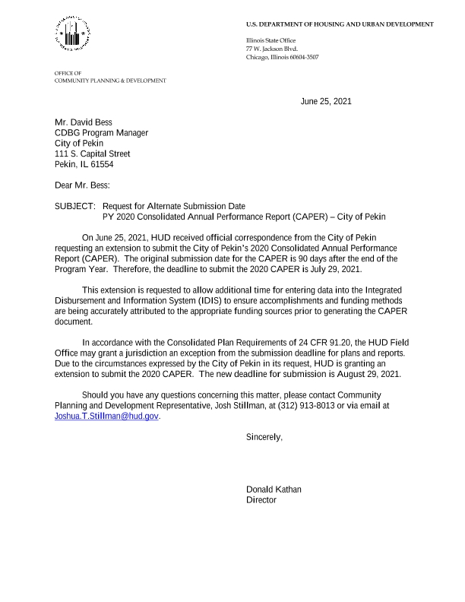
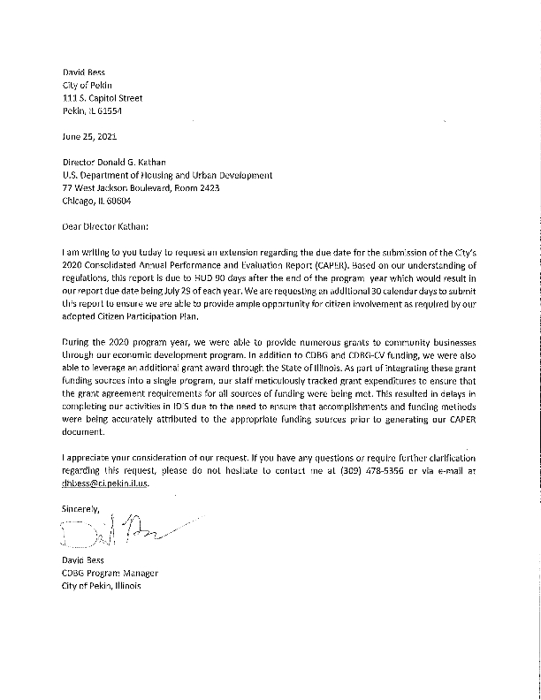

Public Participation Documents
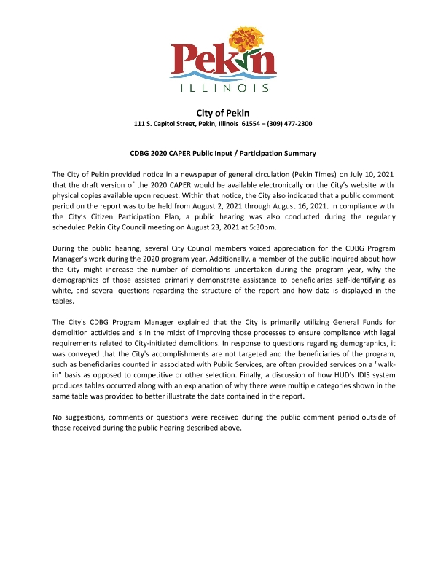
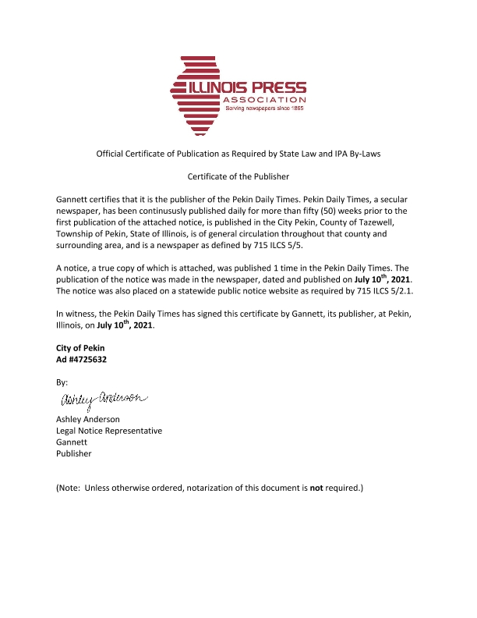
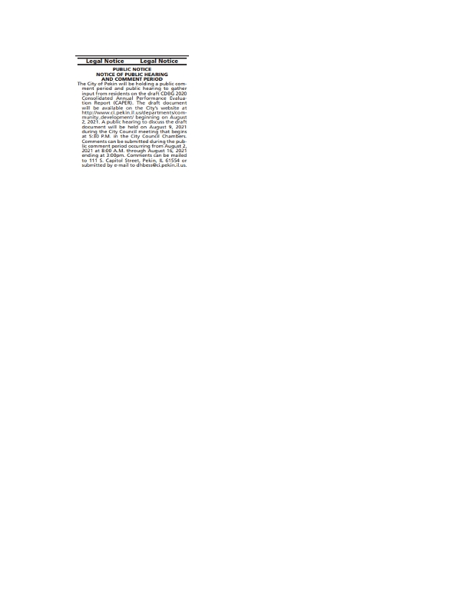

PR-26 Report
